Sreenidhi institute of science & technology
(an autonomous institution under jntuh)
(Approved by AICTE & Aided by World Bank under TEQIP )
Yamnampet, Ghatkesar Mandal, Hyderabad - 501 301.

COURSE FILE

For

SOFTWARE AUTOMATION AND TESTING

For

B. Tech. IV year - I Semester
CSE BRANCH



DEPARTMENT
OF
COMPUTER SCIENCE AND ENGINEERING

1 | 2 | 3 | 4 | 5 | 6 | 7 | 8 | 9 | 10 | 11 | 12
H |  | M | M | M
H: High M: Medium L: Low
Syllabus for B. Tech. IV Year I semester
Computer Science and Engineering
SOFTWARE AUTOMATION AND TESTING
L | T | P | C
2 | 1 | - | 3
Code: 7F719
Course Objectives:
To Understand the Basic concepts in Software testing, concepts of Flow graphs, Path testing and Data Flow Testing, understand the concept of metrics and their types. Understand and implement various testing techniques and to make a thorough study on various testing tools. Set a strategy for testing environment and to learn the testing methodologies in detail.
Course Outcomes:
At the end of this course, the student will be able to
- Describe concepts of Software testing
- Describe and apply the concepts Flow graphs, Path testing and Data Flow Testing.
- Practice Software testing strategy and Environment with economics and apply Software Metrics useful in software development and maintenance.
- Software Testing Methodology, finding defects hard to find, Verification and validation, Functional and structural, Workbench concept, Eight Consideration of software testing methodology, checklist. Describe Agile computing with agile testing
- Demonstrate Software Testing Techniques such as JADs, Pareto Analysis , Regression Tasting, Structured walkthroughs, Thread testing , Performance testing and White box testing.
- Describe Graph matrices and applications, and practice and apply automated testing tools such load Runner, UFT and QTP.

UNIT I
What is Testing, Characteristics of Test Engineers, Software Testing Life Cycle, Levels of Testing, Testing Approaches, Test Cases: Format for Writing Test Case, Test plan: Format to prepare Test plan
Purpose of testing, Dichotomies, Consequences of bugs

UNIT II
Flow graphs and Path testing: Basics concepts of path testing, predicates, path predicates and achievable paths, application of path testing.
Data Flow Testing: Basics of Data flow Testing
Logic Based Testing : Decision Tables

UNIT III
Software testing strategy and Environment, Establishing testing policy, structured approach to testing, Test factors, Economics of SDLC testing.
Software Metrics: Software Quality, Metrics for Analysis Model, Metrics for Design Model, Metrics for source code, Metrics for testing, Metrics for maintenance.

UNIT IV
Software Testing Methodology, Defects hard to find, Verification and validation, Functional and structural, Defects and Failures, Testing that parallels the software Development process, Workbench concept, Eight Consideration of software testing methodology, testing tactics checklist. Importance of Agility, Building an Agile Testing Process

UNIT V
Software Testing Techniques, Black-box, Boundary value, Branch coverage, Cause Effect graphing, CRUD, Database, Histogram, Gray box, Inspections, JADs, Pareto Analysis , Prototyping , Random Testing, Risk based testing , Regression Testing, Structured walkthroughs, Thread testing , Performance testing, Stress Testing, Accepting Testing, White box testing, Alpha and Beta Testing.

UNIT VI
Graph matrices and application: Motivational overview, matrix of graph, relations, power of a matrix, node reduction algorithm.
Need for Automated testing tools, Taxonomy of Testing Tools, Exposure to Software Testing Tools: Load Runner, UFT and QTP.

Text Books
- Software testing techniques – Boris Beizer, Dreamtech, second edition.(Unit 1,2,6)
- Software testing tools – by Dr. K.V.K.K Prasad Dreamtech (Unit 1,6)
- Effective Methods for Software Testing, 2nd Edition by William E.Perry, Wiley publications.(Unit 3,4)
- Software Testing and continuous Quality Improvement, by William E.Lewis,Gunasekaran,2nd Edition Auerbach publications (Unit 5,Refer Internet)
- Software Engineering A practitioner’s Approach, Roger S Pressman, 6th edition. McGrawHill International Edition (Unit 3)

References
- Software Testing Techniques ,by Bories Beizer, Second Edition,Dreamtech Press
- Testing and Quality Assurance for Component based software ,by Gao,Tsao and Wu,Artech House Publishers
- Managing the Testing Process,by Rex Black,Wiley.
- Handbook of Software Quality Assurance, by G.Gordon Schulmeyer,James I.McManus,2nd Edition,International Thomson Computer Press

Department of Computer Science & Engineering
Teaching Schedule
SOFTWARE AUTOMATION AND TESTING

Lecture Schedule
Unit – 1
S.No. | No. of Lectures | Name of the Topic
1 | 1 | Introduction, What is Testing
2 | 1 | Characteristics of Test Engineers
3 | 2 | Software Testing Life Cycle, Levels of Testing.
4 | 1 | Testing Approaches
5 | 2 | Test Cases: Format for Writing Test Case
6 | 1 | Test plan: Format to prepare Test plan
7 | 2 | Purpose of testing
8 | 2 | Dichotomies, Consequences of bugs
Unit – 2
9 | 1 | Basics concepts of path testing,
10 | 3 | Predicates, path predicates and  achievable paths, application of path testing
11 | 3 | Data Flow Testing: Basics of Data flow Testing
12 | 3 | Logic Based Testing : Decision Tables
Unit - 3 |  |  |  | 3 sigma and 6 Sigma
13 | 2 | Software testing strategy and Environment, Establishing testing policy
14 | 1 | Structured approach to testing
15 | 2 | Test factors, Economics of SDLC testing.
16 | 1 | Software Metrics :Software Quality, Metrics for Analysis Model
17 | 3 | Metrics for Design Model, Metrics for source code, Metrics for testing, Metrics for maintenance
Unit – 4
18 | 1 | Software Testing Methodology: Defects hard to find, Verification and validation.
19 | 1 | Functional and structural, Defects and Failures
20 | 1 | Testing that parallels the software Development process
21 | 1 | Workbench concept, testing tactics checklist
22 | 3 | Eight considerations in developing testing methodologies,
23 | 2 | IImportance of Agility, Building an Agile Testing Process
Unit – 5
24 | 1 | Black-Box, Boundary value,
25 | 1 | Bottom-up, Branch coverage
26 | 1 | Cause-Effect graphing, CRUD,
27 | 1 | Database, Gray-Box,
28 | 2 | Inspections, JADs, Alpha and Beta testing
29 | 1 | Prototyping, Random Testing
30 | 1 | Histograms, Pareto Analysis
31 | 1 | Structured Walkthroughs, Thread Testing
32 | 1 | Performance Testing, Regression Testing
33 | 1 | White-Box Testing, Risk based Testing
Unit -6
34 | 2 | Graph Matrices and Application: Motivational Overview
35 | 1 | Matrix of Graph
36 | 2 | Relations and Power of Matrix
37 | 2 | Node Reduction Algorithm
38 | 3 | Exposure to SoftwareTesting Tools: Load Runner
39 | 3 | WinRunner and QTP

Total No. of classes : 64
Available Classes : 65

SOFTWARE AUTOMATION AND TESTING

Course Objectives:

To Understand the Basic concepts in Software testing, concepts of Flow graphs, Path testing and Data Flow Testing, understand the concept of metrics and their types. Understand and implement various testing techniques and to make a thorough study on various testing tools. Set a strategy for testing environment and to learn the testing methodologies in detail.

Course Outcomes: After completing this course, student shall be able to
- Describe concepts of Software testing
- Describe and apply the concepts Flow graphs, Path testing and Data Flow Testing.
- Practice Software testing strategy and Environment with economics and apply Software Metrics useful in software development and maintenance.
- Software Testing Methodology, finding defects hard to find, Verification and validation, Functional and structural, Workbench concept, Eight Consideration of software testing methodology, checklist. Describe Agile computing with agile testing
- Demonstrate Software Testing Techniques such as JADs, Pareto Analysis , Regression Tasting, Structured walkthroughs, Thread testing , Performance testing and White box testing.
- Describe Graph matrices and applications, and practice and apply automated testing tools such load Runner, UFT and QTP.

SOFTWARE AUTOMATION AND TESTING

Unit-1
Short Questions

1. Define Testing ?
2. Explain the characteristics of Testing ?
3. Who are involved in Testing ?
4. Define Test Case ?
5. What is the Test Plan?
6. Give the Levels of Testing?
7. In Requirement phase, what are the different validation activities to be performed?
8. What is the difference between the Testing and Debugging?
9. In Test phase, what are the different validation activities to be performed?
10. In Program phase, what are the different validation activities to be performed
11. In Maintenance phase, what are the different validation activities to be performed?
12. Give the IEEE format to prepare the test cases?
13. Define bug?
14. What is the difference between normal SDLC and SDLC Testing?
15. What are the goals of Testing
16. What are Different phases of Testing?

Essay Questions
1. What is the purpose of testing? List out the various dichotomies and explain.
2. List out the nightmares and explain when to stop testing.
3. What are the principles of test case design? Explain.
4. What is meant by Software Testing? Discuss clearly the purpose of testing.
5. Discuss in detail various phases in a Tester’s Mental life.

6. Explain the importance of bugs.

7 . Write the test plan document for known application.
8. What is test case? Write the test cases to Validate the ATM CARD.
9. Discuss in detail how the consequences of bugs are measured?
10. What are the possible consequences of bugs?
11. Explain in details the factors on which the importance of bugs depend
12. Explain Software Testing Life Cycle(STLC)

Software Testing
Unit-II
Short Questions
1. Define Path Testing.
2. What is Statement Coverage?
3. Define Branch Coverage?
4. What is Data flow Testing
5. What is Decision Tables?
6 Define Predicate and Path Predicate?
7. Define the term Module.
8. What is the accumulated cost for normal SDLC and SDLC testing? Which one is
preferable?

Essay Questions

1. Compare and contrast between control flow graphs and flow charts.
2. Give a detailed note on path testing.
3. Explain applications of paths, path products and regular expressions.
4. What is meant by statement coverage and branch coverage?
5. Discuss the role of decision table in a test case design.
6. Explain in Details about Data flow testing with neat sketch
7. Explain the expansion of the immaterial cases in the decision table. ?

Software Testing
Unit-III
Short Questions

1. What are the two purposes of Testing Policy ?
2. What is the criteria for a Testing Policy ?
3. How many people involved in preparing Testing Policy?
4. How many methods are there to establish a policy?
5. What is the disadvantage of Organizational policy?
6. User Meeting is a what type of policy?
7. In Requirement phase, what are the different verification activities to be performed?
8. In Design phase, what are the different verification activities to be performed?
9. Give the examples for the Factors that can be directly measured?
10. Give the examples for the Factors that can be indirectly measured?
11. Define the terms metric, measurement and measure?
12. Abbreviate FP?
13. Who proposed FP?
14. What are the different parameters for computing FP?
15. Give the formula for FP?
16. What are the different value adjustment factors?
17. Compute the formula for Structural complexity?
18. Compute the formula for Data complexity?
19. Compute the formula for System complexity?
20. Compute the formula for Shape complexity?
21. Abbreviate DSQI?
22. Give the formula for DSQI?
23. Give the formula to compute Overall program length N ?
24. How Program Volume may be defined?
25. Who Proposed the Metrics for source code?
26. Give the formula for Program Level and Effort?
27. Give the formula for Product metric for maintenance?
28. Abbreviate SMI? And give the formula for SMI?
29. What is mean by LOC and KLOC?
30. Formula for DRE?
31. Abbreviate DRE?

Essay Questions
1. Explain how to establish the Testing Policy?
2. Explain various ways to establish a Testing Policy?
3. Explain the Criteria and methods used to establish a Testing Policy?
4. Explain Structured Approach to testing?
5. Explain the Economics of System Development Life Cycle testing?
6. What are the different Test Factors and explain in detail?
7. Explain in detail about Products metrics for Analysis,design, coding, testing and
maintenance?
8. Explain Process Measurements? And give the reasons for measurements?
9. Explain Size oriented Metrics with suitable example?
10. Define FP? And explain the computation of FP?
11. Explain in detail about Metrics for software Quality?
12. Compute the Cyclomatic Complexity with suitable example?
13. Explain how to establish the software quality requirements? And explain how to
implement the collected data?

Software Testing
Unit-IV
Short Questions
1. Give two reasons for defect go undetected?
2. What is mean by user specify the wrong requirements? Justify it
3. What is V & V?
4. Requirement review is performed by whom?
5. Design review is performed by whom?
6. Code inspection review is performed by whom
7. Unit testing is performed by whom?
8. Integration Testing is performed by whom?
9. System Testing is performed by whom?
10. User Acceptance Testing is performed by whom?
11. Functional testing takes whose point of view?
12. What are the components of Workbench?

Essay Questions

1. Explain in detail why Defects hard to find?.
2. Give the differences between below terms
i) Verification Vs Validation
ii) Functional Vs Structural Testing
3. Explain the below terms?
a) Code Walkthrough b) Code inspection c) Unit Testing
d) Integration testing e) System testing f) Formal Review
g) Technical Review
4. Explain in detail about Workbench concept?
5. Explain the Programmer’s workbench concept and list the steps involved in it?
6. Explain the Eight Considerations in Developing Testing Methodology
7. With neat sketch explain Agile Testing process

Software Testing
Unit-V
Short questions

1. What is black box testing?
2. What are the advantages of Black box testing?
3. Black box testing is done by whom?
4. What is white box testing?
5. What is the differences between white box and black box testing ?
6. Black box testing also known as?
7. What is gray box testing?
8. What is white box testing?
9. What is Sandwitch testing?
10. What is performance testing?
11. Abbreviate BVA and EP?
12. What is incremental integration testing?
13. What is Regression Testing?
14. What is Alpha and Beta Testing?
15. What is bottom-up integration testing?
16. What is top-down integration testing?
17. what is thread testing?
18. what is Random testing
19. What is Risk based testing?
20. Define the term ‘UNIT TESTING’.
21. Define the term ‘COMPONENT TESTING’.
22. Define the term ‘INTEGRATION TESTING’.
23. Define the term ‘SYSTEM TESTING’

Essay Questions

1. Explain different software testing techniquces?
2. Explain the below terms
i) White box testing ii) Black box testing iii) Gray box testing
3. Explain Cause Effect Graphing with suitable example?
4. What is integration testing? And explain the different types of integration testing?
5. Abbrevate CRUD and explain?

6. Give the brief note for the following
a) Histograms
b) Pareto Analysis
7. What is system testing? And explain different techniques used to perform system testing?
.
Software Testing
Unit-VI
Short Questions
1. What is a graph matrix?
2. Write the node reduction algorithm.
3. What is partitioning algorithm?
4. What are matrix operations?
5. What are partial order relations?
6. What is Ad-hoc testing?
7. What is usability testing?
8. What is User-Acceptance testing?
9. What is Automation?
10. What does a predicate calculator do ?
11. What does a logic analyzer do ?
12. What does a domain processor do ?
13. Advantages of Automation testing?
14. Differences between Manual and Automation testing?
15. What are the different bug tracking tools?
16. What are the different test management tools?
17. What is SRS?
Essay Questions

1. Explain in detail the node reduction algorithm.
2. Explain all the relations that exist in matrix of a graph.
3. Explain partitioning algorithm.
4. Explain the different categories of testing tools available in market?.
5. Explain the Methodology to evaluate automated testing tools?
6. Majority of testing is done manually why? What is the difference between manual testing
and Automation testing?
7. Write the node-by-node removal algorithm for converting a flow graph into path expression

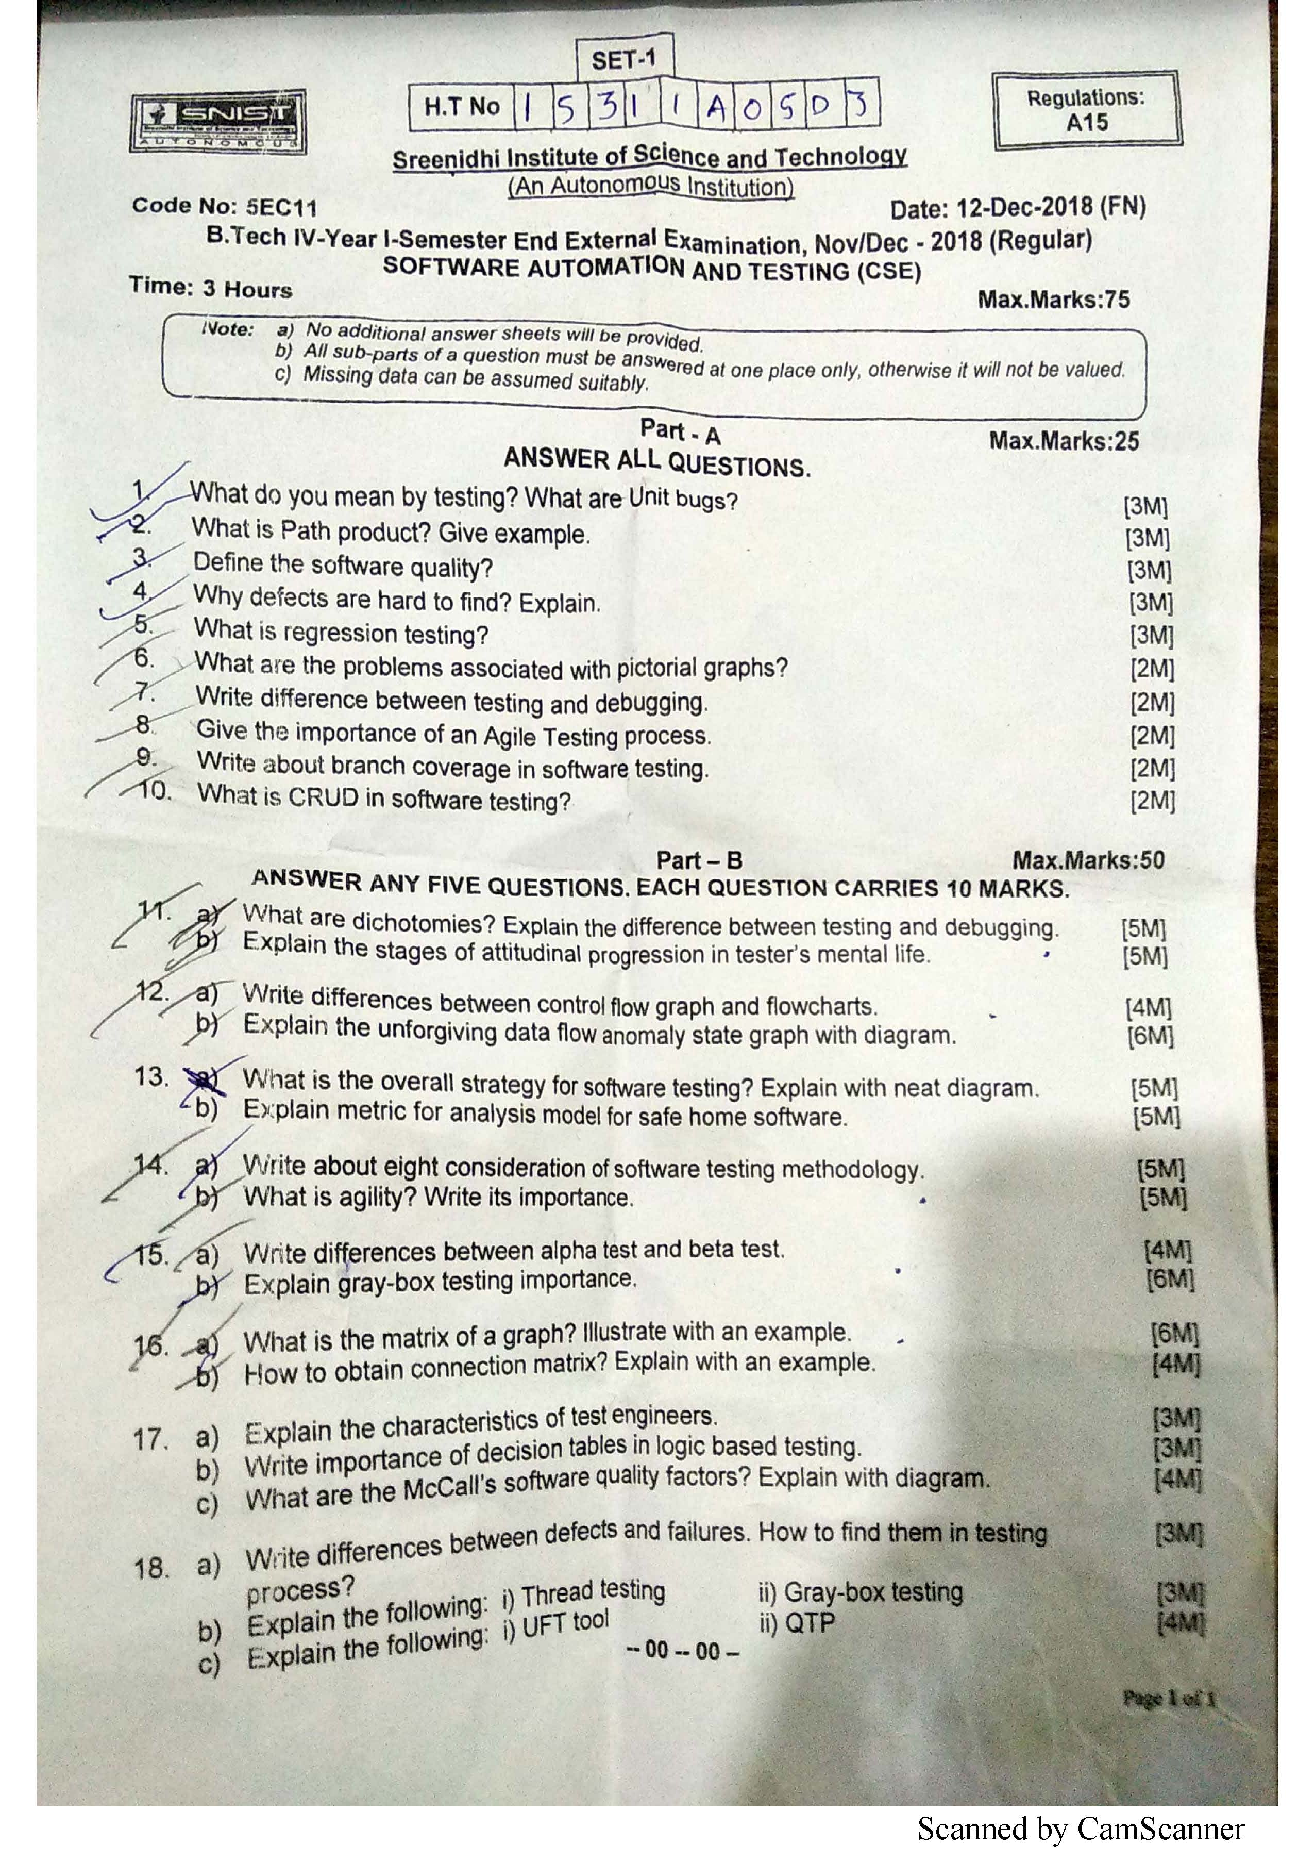

H.T No
Regulations:
A17

Sreenidhi Institute of Science and Technology
(An Autonomous Institution)
Code No:6EC11 Date: 15-Mar-2021(FN)

B.Tech IV-Year I- Semester External Examination, March/April - 2021 (Regular)
SOFTWARE AUTOMATION AND TESTING (CSE and IT)

Time: 3 Hours Max.Marks:75

Note: a) No additional answer sheets will be provided.
b) All sub-parts of a question must be answered at one place only, otherwise it will not be valued.
c) Missing data can be assumed suitably.

ANSWER ANY 5 OUT OF 8 QUESTIONS. EACH QUESTION CARRIES 15 MARKS.

Bloom's Cognitive Levels of Learning (BCLL)

Remember | L1 | Apply | L3 | Evaluate | L5
Understand | L2 | Analyze | L4 | Create | L6

 |  |  | BCLL | CO(s) | Marks
1. | a) | Discuss the various levels of testing in detail. | L2 | CO1 | [8M]
 | b) | Summarize the beliefs that many programmers and testers have about bugs? | L2 | CO1 | [7M]
2. | a) | What is data flow testing? Explain with a sample snippet of code. | L2 | CO2 | [8M]
 | b) | Discuss the various cases in loops for performing path testing. | L2 | CO2 | [7M]
3. | a) | Define metric. Discuss in detail the various metrics for analysis model. | L2 | CO3 | [8M]
 | b) | Devise a testing strategy taking into consideration a case study like an online shopping cart application. | L6 | CO3 | [7M]
4. | a) | What are the steps involved in building an agile testing process? Discuss. | L2 | CO4 | [8M]
 | b) | Explain in detail the eight considerations of software testing methodology. | L2 | CO4 | [7M]
5. | a) | Discuss the various black box testing techniques with appropriate examples. | L2 | CO5 | [8M]
 | b) | What is cyclomatic complexity? Discuss its use in statement coverage testing. | L2 | CO5 | [7M]
6. | a) | Explain the node reduction algorithm using an example. | L2 | CO6 | [8M]
 | b) | Give the taxonomy of automated testing tools. | L2 | CO6 | [7M]
7. | a) | Write a brief note on the consequences of bugs. | L1 | CO1 | [5M]
 | b) | Describe fundamentals of Path Selection Criteria with example. | L1 | CO2 | [5M]
 | c) | Write short notes on metrics for maintenance of software. | L1 | CO3 | [5M]
8. | a) | Discuss the importance of Agility in testing. | L2 | CO4 | [5M]
 | b) | What is Regression Testing? Explain how and when is it performed? | L2 | CO5 | [5M]
 | c) | Write short notes on QTP. | L1 | CO6 | [5M]

